Conclusions

1. On average games were the least likely to have a successful crowdfunding campaign, despite on average having the most backers and a high average donation. Games also had the highest average goal which would have contributed to the lower success rate.
2. Crowdfunding campaigns with a higher goal failed at a much higher rate. The average goal for a successful US campaign was $25,697 while the average for a failed campaign was significantly higher at $64,939.
3. The average donation by each backer did not have a strong impact on the success or failure of the campaign, however the number of backers did have a strong impact. Successful campaigns averaged 326 more backers per campaign across all categories in the US.

Limitations of Data Set

One limitation is having multiple currencies and countries in the same data set. It would be a little easier to compare the entire data set if we used exchange rates to convert to a common currency. Adding a column for length of campaign using the start and end dates could also yield some useful data to determine optimal length of future campaigns. I would also like to see what crowdfunding service each campaign used, and if they used multiple sites. This could be valuable data to use when determining what site to use for an upcoming campaign.

Other possible tables and graphs

I would like to see some pie charts of success rate that can be filtered by parent category or sub-category.

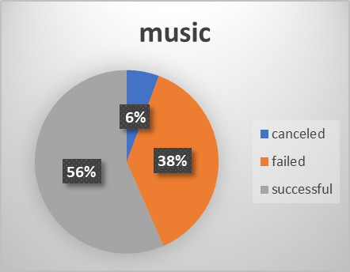

There are a lot of different tables and charts a person could make from this data, but one more I would like to see is a representation of what the average goal was across all categories and how that compared to the average goal of campaigns that were successful or not.

